The Big Issue
(http://www.walesonline.co.uk/news/wales-news/big-issue-sellers-cardiff-stories-12237286 )
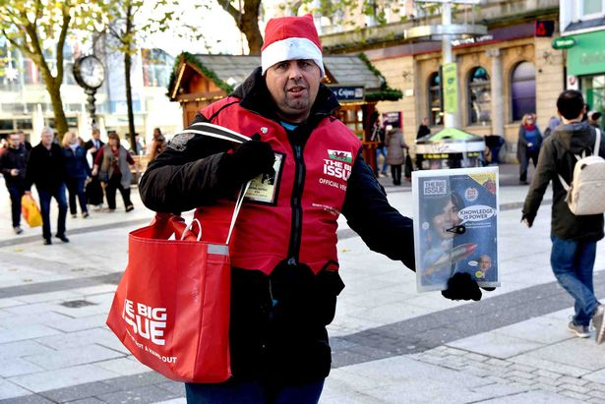
Discuss with your partner:
- Have you ever bought this magazine?
- What do you know about this magazine?
- What do you know about the people who sell this magazine?

Read about a man who sells the Big Issue and answer the questions.
Mark Richards started selling the Big Issue five years ago after spending years begging on the streets and sleeping in the shadows of Cardiff Castle.
“I had spent 24 years living with my mum and dad and my brother in Cambridge,” he said.
“But they saw me as a black sheep.”
Mark said his family problems reached boiling point when he was left alone in the house one weekend.
Mark said he had thrown a party that became wildly out of control. Strangers ransacked his house and stole his parents’ possessions.
“When they came back and the house was empty they blamed me. I had to go after that,” he said.
Mark travelled to Cardiff in the hope of staying at a friend’s house but ended up on the streets, begging and shoplifting to survive.
But in 2011, he was approached by a sales manager from the Big Issue and started earning a living selling magazines.
He said: “I decided, rather than sitting on street corners begging for change, I’d try to improve my circumstances.”
He now sells Big Issues outside Sainsbury’s on Queen Street.
“Sometimes on a good day, you’ll sell about 50. Other days, you’ll be lucky to sell one or two.
“Sometimes they swear at us, they say: ‘get a f****** job.’ And I think: ‘What do you think this is?’”
He said one of the worst experiences he had was on Cardiff University’s graduation day when he tried to sell a magazine to a father of one of the students.
“I said ‘good afternoon sir, would you like a copy of the Big Issue?’ and he said ‘no thank you’. But then he turned around and said: ‘I’m glad my daughter didn’t turn out like you.’”
One week ago, Mark was shocked by the news that his father had died. He hadn’t spoken to him in more than 20 years.
“Even though I hadn’t seen him, it was still was a very hard time for me,” he said.
Despite abuse, Mark said he enjoyed selling magazines and having the chance to earn his own money.
Through the Big Issue, he has now saved up enough to rent a flat.
“I’m always friendly and I try and chat to my customers.
“This year I’m dressing up as a Christmas pudding. I’m hoping it will make people smile.”

1. Why did Mark move out of his parent’s home?
- he was a black sheep
- he had shoplifted
- his parent’s house was damaged
- he was left alone all the time

2. Why did Mark decide to sell the big issue?
- he couldn’t stay at his friend’s house any longer
- he wasn’t happy with his life
- the manager asked him to
- he wanted to sit on the streets

3. What doesn’t Mark like about the job?
- he doesn’t sell many magazines
- people don’t treat him with respect
- he can’t sell magazines to students
- people tell him to go away
4. According to the text, which of the following statements is true?
- he has been homeless for 5 years
- the last time he had contact with his father was over 20 years ago
- he would prefer not to sell the magazine anymore
- he will be moving to a new house soon

Put these events (a-l) in the order that they happened (1-12), according to the text.
- His parents thought he was responsible for their items going missing
- He had a bad experience with a student’s father
- He travelled to Cardiff
- He chose to make a better life for himself
- He has money to rent a flat
- People he didn’t know came into the house
- He lived with his mum, dad and brother
- He was left alone in his parent’s house
- His father died
- He heard the news about his father
- He thought he could stay at his friend’s house
- He started selling the Big Issue

Choose the 6 most important things that happened to Mark from the sentences above.
Use those 6 sentences to help you write a summary. Remember to use linking words. You can change the vocabulary and grammar.
________________________________________________________________________________________________________________________________________________________________________________________________________________________________________________________________________________________________________________________________________________________________________________________________________________________________________________________________________________________________________________________________________________________________________________________________________________________________________________________________________________________________________________________________________________________________________________________________________________________________________________________________________________________________________________________

The Big Issue – Maurice
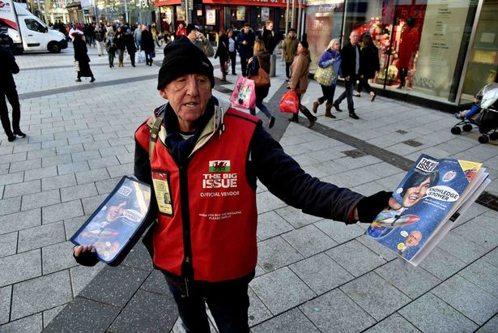
Before selling the Big Issue, Cardiff-born Maurice had spent 10 years working on a building site. But last year, he was forced to give up work after developing emphysema (a disease of the lungs).
“All the dust on the building site caused me to have problems with my lungs and I was forced out. I ended up in a crisis. I went into the Big Issue’s office and next thing you know, I’m here selling.”
Maurice now sells along Queen Street.
“There’s so many kind people out there,” he said.
“If you are polite, they’re polite back to you. I try to treat everybody with respect."
Maurice said he sees selling the Big Issue as a full-time job.
“Somebody’s offered me food vouchers and I said no. I’m too proud to take it,” he said.
“I want to make money for myself. I’ve got small granddaughters, I want them to be proud of me.”
He said he’s enjoyed the new opportunities he’s had through the Big Issue. He’s had the chance to be a referee in a All Wales homeless football league, and he recently featured in a photo exhibition by singer and photographer Bryan Adams.
Maurice is currently living in a sheltered hostel in Riverside.
“It’s horrible there, I shouldn’t be there. I don’t take drugs or drink alcohol all day. But I take everything as it comes. It’s better than the alternative which is begging on the streets.”
Underline the main points of Maurice’s story.

Choose 5 of the main sentences (underlined) and write them in your own words here.
________________________________________________________________________________________________________________________________________________________________________________________________________________________________________________________________________________________________________________________________________________________________________________________________________________________________________________________________________________________________________________________________________________________________________________________________________________
Use your summary above to tell Maurice’s story to your partner.
Your partner should be able to repeat the story back to you.

